Task 4. Microsoft Disk Operating System (MS-DOS) Commands

- Introduction:

Directory: A catalog for filenames and other directories stored on a disk.

File: A named collection of data stored on disk, appearing to the user as a single unit. It is a group of related records in a database. In relational database, it is called as ‘Table’.

NOTE: DOS is not case sensitive (i.e. DOS commands can be entered in uppercase or lowercase)

- Types of DOS Commands

MS DOS commands mainly categorized into 2 types
1. Internal Commands
2. External Commands

- Internal Commands
→These commands are generally loaded when an operating system itself is loaded into the memory. So these commands are stored in computer main memory.
Ex: DIR, COPY, DEL, REN, MD, CD, RD, REN etc.
→Internal commands are also known as ‘Intrinsic Commands’.

2. External Commands
- →These Commands are stored in Disk files. Stored in secondary memory like disk.
- Ex: SYS, TREE, XCOPY, FORMAT, DISKCOPY, CHKDSK, LABEL etc.
- →External commands are also known as ‘Extrinsic Commands’.

- How to start DOS

- Start -> Programs -> Accessories -> Command Prompt
- (or) Start -> Run… -> enter ‘cmd’ or ‘command’ in the text box

- File Naming Conventions

- A filename has 2 parts:
(a) Primary Name
(b) Secondary Name (Extension)
- A dot (.) separates a primary name from extension.
- Ex: anitha.doc
- It is optional to give an extension to a filename.
- 1. Primary name cannot have more than 8 characters and extension can have a maximum of 3 characters

2. A filename can contain the following characters:
• An Alphabet (A-Z) or (a-z)
• A number (0-9)
• Special Characters such as $, #, &, @, !, %, (, ), ~, {, }, ‘, ^ etc
except *, ?,fullstop (.) and space ( )

- Internal/Intrinsic Commands

- Directory Manipulation Commands of DOS

- DIR command :
Purpose: it displays a list of files or directories present on a disk.
Syntax: D:\> DIR <Enter>
It displays
1. Primary Name
2. Extension
3. Size of each file in bytes
4. Date when the file was either created or modified last
5. Time when the file was either created or modified last

Ex:D:\> Dir
Output:
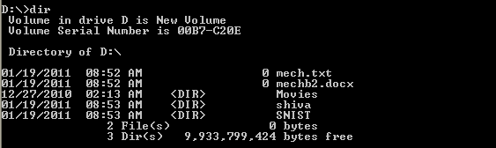

- Ex: D:\>DIR/P -> it shows the contents of the disk page-wise
- Ex: D:\>DIR/W -> it shows the contents of the disk width-wise. It displays only filenames not date, time, size of file etc. directories are shown in square brackets ([ ]).
- Ex: DIR/A– Display files with specified attributes.
- Ex: DIR/D – same as wide but files are list sorted by column.
- Ex: DIR/Q – Display owner of the file

2. MD command :
Purpose: is used to create (make) a directory
Syntax: D:\>MD <directory-name>
Ex:D:\>md mechB2

Output:
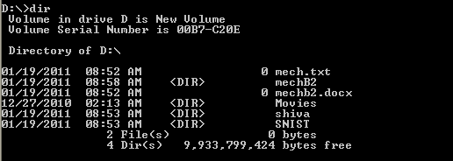

Ex: D:\>MD mechB2\mech1-> it creates a sub-directory ‘mech1’ under ‘mechB2’ directory

3. RD command :
Purpose: to remove (delete) a directory
Syntax: D:\>RD <directory-name>

Ex: D:\>RD mechB2
Output:
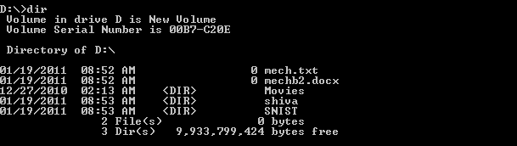
- NOTE: A directory or sub-directory has to be empty before removing it.

4. CD command :
Purpose: To change directory
Syntax: D:\>CD <directory-name>

Ex: D:\>CD mechB2 -> it change to ‘mechB2’ directory
Output:

D:\>CD mechB2\mech1\mech2

Output:
NOTE:
D:\>CD\ -> it goes to root directory (from any level)
D:\>CD.. -> it goes only one level up
D:\>CD -> it displays current directory name
D:\>CD <directory-name> -> to change directory

- File Manipulation Commands of DOS

- COPY command:
Purpose: To copy a file

Syntax: COPY <source drive> <destination file>
Ex: D:\>mechB2\mech1\mech2>copy snist.txt mech.txt
Output:
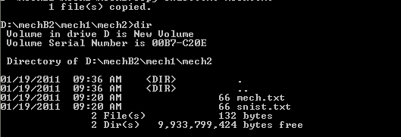

Syntax: COPY <source drive>:<file spec1> <target drive>:<file spec2>
2. DEL command:
Purpose: To delete a file
Syntax: D:\>DEL <filename>
Ex: D:\>mechB2\mech1\mech2>del mech.txt
Output:
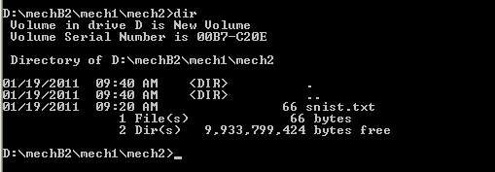
3. REN command :
Purpose: To rename a file
Syntax: D:\>REN <old-filename> <new-filename>
Ex: D:\>mechB2\mech1\mech2>ren snist.txt mechb2.txt
Output:
- 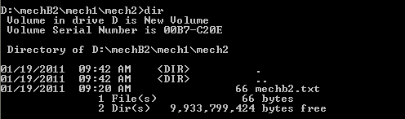

- Commonly used DOS commands:

- DATE command :
Purpose: It displays system date
Syntax: D:\>DATE
Ex: D:\>mechB2\mech1\mech2>date
Output:
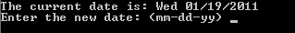
If user enters new date, it changes system date

2. TIME command :
Purpose: It displays system time
Syntax: D:\>TIME
Ex: Ex: D:\>mechB2\mech1\mech2>time
Output:
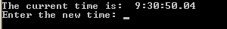
If user enters new time, it changes system time

3. CLS command :
Purpose: To clear the screen
Syntax: D:\>CLS
Output:
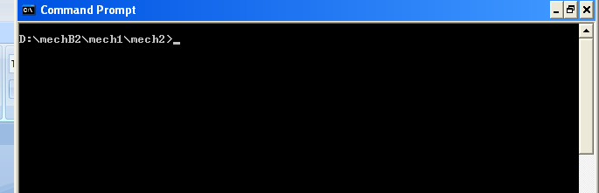
4. COPY CON command :
Purpose: To create a file at command prompt
Syntax: D:\>COPY CON <filename>
Ex: D:\>mechB2\mech1\mech2 copy con snist.txt

Output:
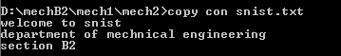

Note: Press CTRL+Z to save and exit command
(ii). EDIT command -> to create a file in DOS editor
Syntax: D:\>EDIT <filename>
Ex: D:\>mechB2\mech1\mech2 edit snist.txt

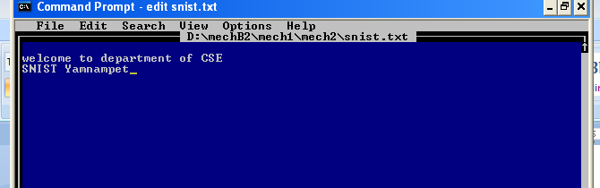
5. TYPE command -> to view the contents of a file
Syntax: D:\>TYPE <filename>
- Ex: D:\>mechB2\mech1\mech2 TYPE snist.txt -> it displays the contents of snist.txt file on the screen
Output:
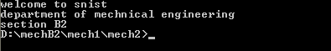

6. ECHO Command:
Purpose: to display a message on the screen while executing a set of commands.
Syntax: C:\> Echo <message>
Ex: C:\>Echo welcome to snist
Output: welcome to snist

- External/Extrinsic Commands (Disk Manipulation Commands)

- FORMAT command :
Purpose: It is used for formatting a hard disk or floppy disk
Syntax: C:\>FORMAT A:
Ex: C:\>FORMAT A:/S -> with this command, all the OS files (COMMAND.COM and 2 hidden files) are copied from the hard disk to the floppy disk.
NOTE: This command needs the program file FORMAT.COM
Format -> The organization of disk into tracks and sectors is called Formatting.

2. CHKDSK command :
Purpose: to check the status of the disk.
Syntax: C:\>CHKDSK A:
NOTE: If no drive letter is specified with CHKDSK command, then the currently active drive is checked.

3. LABEL command:
Purpose: A volume label to the disk is given at the time of formatting the disk.
Syntax: C:\> LABEL A:
NOTE: This command needs the program file LABEL.COM

4. DISKCOPY command:
Purpose: it copies all the contents of one disk onto the other.
Syntax: C:\> DISKCOPY A: A:
NOTE:
1. if there is a single drive on the computer, then the same can act as source as well as destination
2. This command needs the program file DISKCOPY.COM
3. DISKCOPY command works with floppy disk and not with hard disk and both floppies should of same capacity.

Task 5. LINUX Commands

1. ls Command:

Ex: $ ls -> it displays list of files & directories

Output:

Desktop dwhelper Music Public Templates
Documents examples.desktop Pictures snist.c Videos

- $ ls -l -> it displays list of files & directories with permissions (r, w, x permissions)

2. mkdir command:-- to create a new directory

Syntax: #mkdir <directory-name>

Ex: #mkdir mechb2

Output:
Desktop dwhelper mechb2 Pictures snist.c Videos
Documents examples.desktop Music Public Templates

3. rmdir command:-- to remove a directory

Syntax: #rmdir <directory-name>

Ex: #rmdir mechb2

Output:
Desktop dwhelper Music Public Templates
Documents examples.desktop Pictures snist.c Videos

4. cd command: -- to change directory

Syntax: #cd <directory-name>
Ex: #cd MechB2

- cd\ -> to go to root directory
Syntax: #cd\

5. rm command -> to remove a file

Syntax: #rm <file-name>

Ex: #rm snic.c
Output:
Desktop dwhelper Music Public Templates
Documents examples.desktop Pictures snist.c Videos

6. cp command -> to copy a file

Syntax: #cp <file-name1> <file-name2> -> it copies contents of file1 to file2

Ex: #cp snist.c snis.c -> it copies contents of snist.c file to snis.c file

Output:
Desktop dwhelper Music Public snist.c Video
Documents examples.desktop Pictures snis.c Templates

7. mv command -> to rename a file

Syntax: #mv <file-name1> <file-name2>

Ex: D:\>mechB2\mech1\mech2>mv snis.c snist.c
Output: Desktop dwhelper Music Public Templates
Documents examples.desktop Pictures snist.c Videos

8. cat command -> to create a file, display a file, join 2 files, join 2 files and create a new

file and keep whole content in new file

(i). Syntax: #cat><file-name> -> to create a file

Ex: #cat> MechB2

Enter the text and press <Ctrl+Z> keys together to save file. Ctrl+Z keys tell operating system that no more text is going to be entered.

(ii). Syntax: #cat <file-name> -> it displays the contents of a file

Ex: #cat MechB2

(iii). Syntax: #cat <file-name1> <file-name2> -> it concatenates (joins) 2 files file1, file2

Ex: #cat MechB2 MechB1

(iv). Syntax: #cat <file-name1> <file-name2>><file-name3> -> it concatenates (joins) 2 files

file1, file2 and creates a new file (file3) and put the whole content in new file

Ex: #cat MechB2 MechB1>Mech

9. vi command -> to create a file in Linux editor (vi editor)
Syntax: #vi <filename>
Ex: #vi MechB2.txt

Note:

1. :w (or) :w! -> it saves a file and still remains in that file

2. :q (or) :q! -> it quits ‘vi’ editor without saving

3.:wq (or) :wq! (or) ZZ -> it saves a file and quits ‘vi’ editor

10. grep command -> to search for a specified pattern in a file such as a particular word or phase

Syntax: #grep <text> <file-name>
Ex: #grep SNIS MechB2

11. sort command -> to sort the contents of a file

Syntax: #sort <file-name>
Ex: #sort MechB2

12. lp command -> printing files

Syntax: #lp <file-name>
Ex: #lp MechB2
Ex: #lp MechB2 MechB1 -> it prints 2 files
NOTE: User can print more than 1 file using single lp command

Linux Utilities:

1. banner command -> it makes posters
Syntax: #banner <text>
Ex: #banner KIT

2. cal command -> it displays calendar
Syntax: #cal
Output:
January 2011

Su Mo Tu We Th Fr Sa

1
2 3 4 5 6 7 8
9 10 11 12 13 14 15
16 17 18 19 20 21 22
23 24 25 26 27 28 29
30 31
Ex: #cal -> it displays current month calendar
Ex: #cal 2004 -> it displays all 12 months of 2004

3. date command -> it displays date & time
Syntax: #date
To display current date
Ex: snist@snist-desktop:~$ date

Output:
Wed Jan 19 12:46:24 SCT 2011

4. who command -> it prints the login name of the person on the system
Syntax: #who

Ex: snist@snist-desktop:~$ who

Output:
ravi tty7 2011-01-19 12:32 (:0)
ravi pts/0 2011-01-19 12:36 (:0.0)

5. tty command -> it displays the name of the terminal
Syntax: #tty
Ex:snist@snist-desktop:~$ tty

Output:
/dev/pts/0

6. uname command -> it displays name of the current Linux system
Syntax: #uname
Ex:snist@snist-desktop:~$ uname

Output:
Linux

7. Echo command:
Syntax: #echo <text>
Ex: #echo SNIST
Output:
SNIST

8. pwd command -> it prints working directory
Syntax: #pwd
Ex: snist@snist-desktop:~$ pwd

Output:
/home/ravi

9. man command -> it displays on line help
Syntax: #man

10. clear command -> to clear the screen
Syntax: #clear the terminal

11. wc command -> it displays no. of lines, words, characters of a file
Syntax: #wc <filename>
Ex: snist@snist-desktop:~$ wc snist.c

Output:
1 1 8 snist.c

